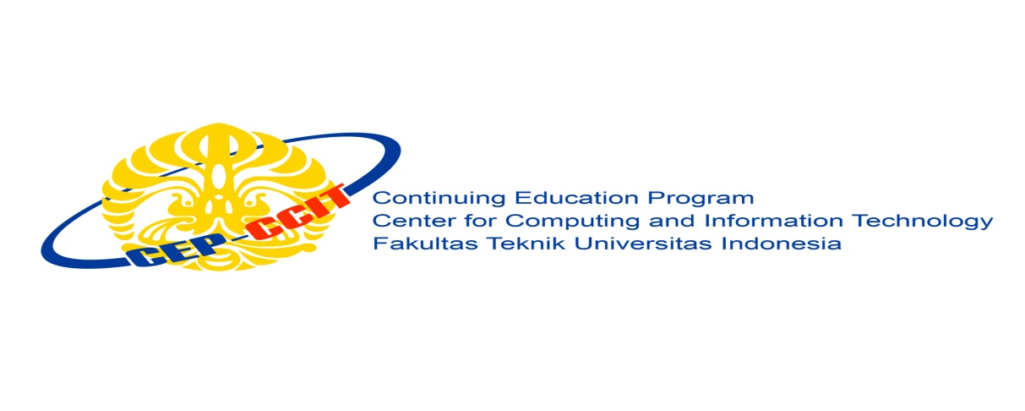

**Information Search and Analysis Skills**

**(ISAS)**

**LINUX MINT OS**

Name : 1. Hilman Maulana Anhar

2. Muhamad Dani Setiawan

Faculty :

Semester : 1

Quarter : 1

Class : 1SC8

Continuing Education Center for Computing and Information Technology Faculty of Engineering, University of Indonesia

2018